|  |  |  |  |  |  |  |
| --- | --- | --- | --- | --- | --- | --- |
| case | test score 1 | test score 2 | test score 3 | total | average | prediction |
| 1 | 60 | 50 | 83 | 193 | 64.33333333 | Should get correct totals |
| 2 | 190 | 80 | 90 | 360 | 120 | should reject |
| 3 | -40 | 90 | 30 | 80 | 26.66666667 | should reject |
| 4 | 75 | 89 | 92 | 256 | 85.33333333 | should work |

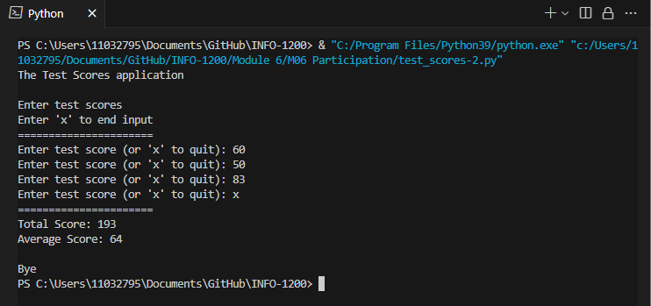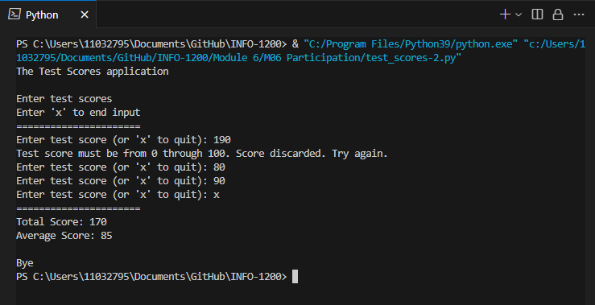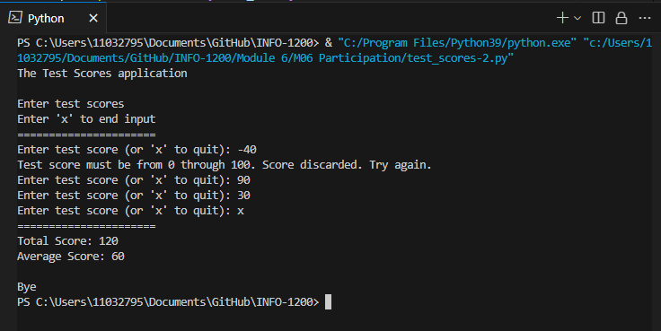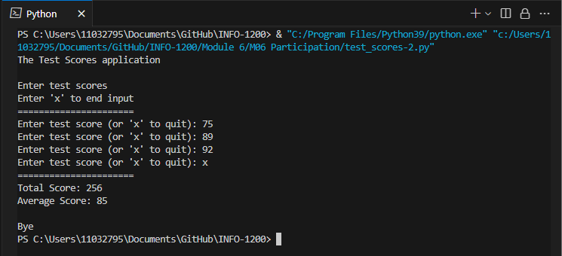

# Part 2 – MO6

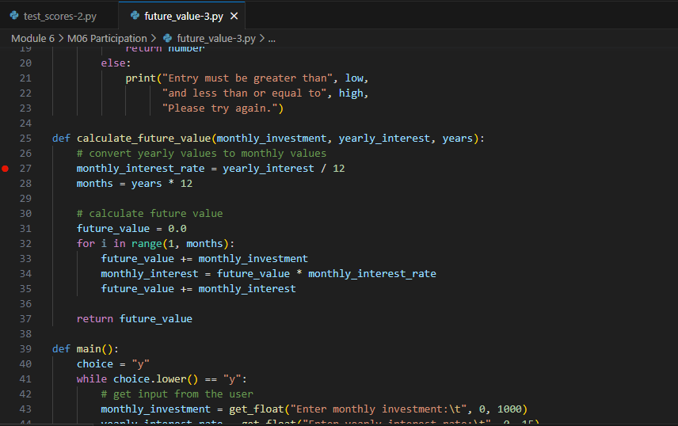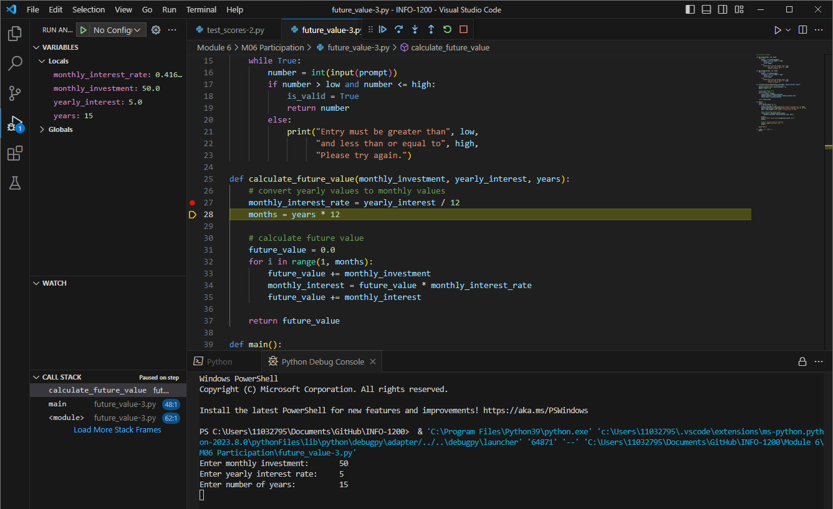All I did was divide yearly interest by 100 to make it work as a percentage. And add 1 to months so it goes through the correct number of months.

